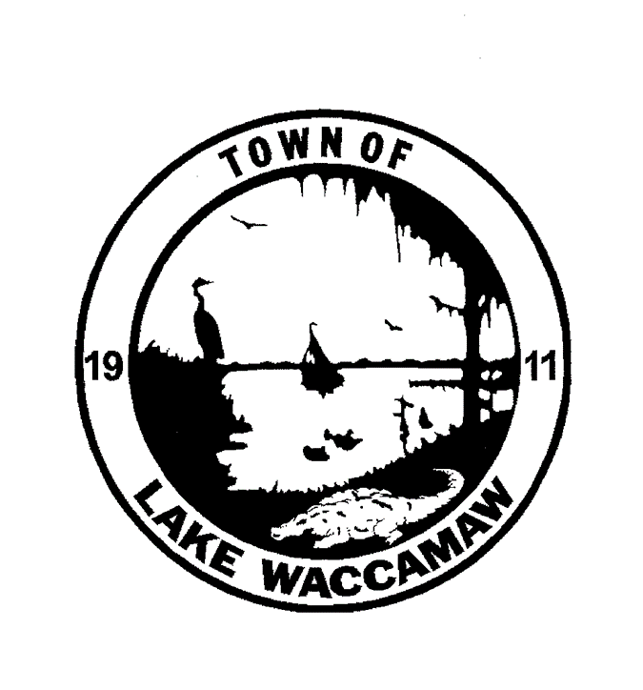
PWS ID #NC 04-24-045

Please be advised water outages may occur Monday, April 15, 2024 due to the NCDOT Road Construction Project on Chauncey Town Road. Projected outages should occur after 10pm with restoration no later than 4am.

Water consumers of the Lake Waccamaw Water System in Columbus County are experiencing periods of low pressure and outages in the distribution system due to a loss of pressure in the Town of Lake Waccamaw. Periods of low or no pressure in the distribution system increase the potential for back siphonage and introduction of bacteria into the water system.

Therefore, the Division of Water Resources advised that when water is restored consumers boil all water used for human consumption (including drinking, making ice, brushing teeth, washing dishes, and food preparation) or use bottled water.
Vigorous boiling for one (1) minute should kill any disease-causing organisms that may be present in the water.

This office is strongly urging the water consumers to conserve water whenever possible. This advisory remains in effect until further written notifications is issued.

This advisory is issued for the entire Town of Lake Waccamaw. The boil water notice will be rescinded as soon as the results of the sample are received. Notifications will be through news outlets, posted in commercial locations and the Lake Waccamaw home page at www.lakewaccamanc.gov.

By: Town of Lake Waccamaw

Kevin Powell____________
(Contact Name)
4/15/2024 Lake Waccamaw_________
(Water System Name)
910-646-3700___________
(Contact Phone Number)

cc: Regional Engineer, Public Water Supply Section, Wilmington Regional Office
Columbus County Health Department

