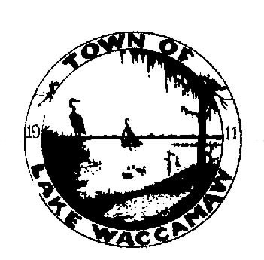
Town of Lake Waccamaw

ON THE SHORES OF NORTH CAROLINA’S LARGEST NATURAL LAKE

P.O. Box 145
Lake Waccamaw, North Carolina 28450
(910) 646-3700
(910) 646-3860 Fax
email: lwtownmanager@embarqmail.com Member N.C. League of Municipalities

PWS ID #NC 04-24-045

System Pressure Advisory Rescinded

02/9 /2023 1:15 PM
Date Time

Based on the laboratory analysis of water samples collected from the Lake Waccamaw Water System on February 7, 2023, water users are hereby notified that it is no longer necessary to boil water used for human consumption. The system has resumed normal operations. The affected area was from Columbia Avenue to Bella Coola Rd, and includes Lakeshore Drive, Schley Avenue, Pecan Avenue, Grove Circle, Robeson Avenue, Arena Drive, Maple Street, Pine Street, Lakewood Avenue, Birch Street, Elm Street, Myrle Drive, Cedar Street, Council Avenue, Jefferson Road, Creek Ridge Road and Bella Coola Road.

We appreciate your cooperation during this period. If you have any questions, please feel free to contact us.

Kevin Powell
(CONTACT NAME)
02/9/2023 Lake Waccamaw
(WATER SYSTEM NAME)
910-646-3700
(CONTACT PHONE NUMBER)

cc: Regional Engineer, Public Water Supply Section, Wilmington Regional Office
Columbus County Health Department

